Week 1 Day 3
LO: To recognise the relationship between addition and subtraction.

For each model, write 4 number sentences. 2 will use addition. 2 will use subtraction.
Guided:
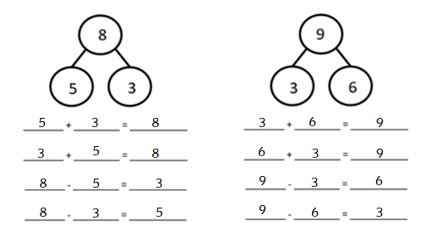
Independent:
10
8
2
_______ + ________ = __________
_______ + ________ = __________
_______ - ________ = __________
_______ - ________ = __________

7
5
2
_______ + ________ = __________
_______ + ________ = __________
_______ - ________ = __________
_______ - ________ = __________

10
6
4
_______ + ________ = __________
_______ + ________ = __________
_______ - ________ = __________
_______ - ________ = __________

7
3
4
_______ + ________ = __________
_______ + ________ = __________
_______ - ________ = __________
_______ - ________ = __________

9
8
1
_______ + ________ = __________
_______ + ________ = __________
_______ - ________ = __________
_______ - ________ = __________

8
2
6
_______ + ________ = __________
_______ + ________ = __________
_______ - ________ = __________
_______ - ________ = __________

10
3
7
_______ + ________ = __________
_______ + ________ = __________
_______ - ________ = __________
_______ - ________ = __________

7
1
6
_______ + ________ = __________
_______ + ________ = __________
_______ - ________ = __________
_______ - ________ = __________

9
4
5
_______ + ________ = __________
_______ + ________ = __________
_______ - ________ = __________
_______ - ________ = __________

8
1
7
_______ + ________ = __________
_______ + ________ = __________
_______ - ________ = __________
_______ - ________ = __________

