Week 2 Day 4 LO: To count to 20

**How many ladybirds?**

________



**How many flowers?**

________



**How many bees?**

________

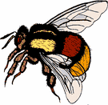

**How many caterpillars?**

________



**How many dragonflies?**

________



**How many butterflies?**

________

